Tittle Here, Calibri Bold, 20pt Title Case, Aligned Left
Subtitle here, calibri bold, 14pt sentence case, aligned left

First Author¹, Second Author^{2,} and Third Author³ (Calibri Bold 11pt., aligned left)
¹Full affiliation of first author, including country (in English, Calibri 9pt, aligned left)
²Full affiliation of second author, including country (in English)
³List all affiliation in the same way (in English)

ABSTRACT
Text: Calibri 10pt justified; 13pt line spacing, 6pt after paragraph. Abstract should outline the purpose of the article, method of the research, data and main results. Lorem ipsum dolor sit amet, consectetur adipiscing elit. Morbi vulputate porta tristique. Suspendisse dictum iaculis molestie. Lorem ipsum dolor sit amet, consectetur adipiscing elit. Vivamus id congue metus. Aliquam commodo tristique dictum. Aliquam dapibus sem eu semper vulputate. Sed eget enim tellus. Vestibulum laoreet, elit id condimentum euismod, justo ex ullamcorper ipsum, at vehicula neque neque non massa. Phasellus gravida felis justo, ac suscipit leo finibus in.
Curabitur eget arcu felis. Sed elementum tincidunt lobortis. Nulla nisl nibh, semper non lacus vitae, malesuada fermentum diam. Ut eu ipsum non augue tristique eleifend. Nam auctor erat eu augue faucibus tincidunt. Ut cursus odio id placerat pretium. Nam condimentum quis tortor non placerat. Praesent libero purus, interdum eu risus quis, maximus maximus nisi.

KEYWORDS
Keyword 1, Keyword 2, Keyword 3 (max 5 key words in English)

1. INTRODUCTION
Text: Calibri 11pt justified; 16pt line spacing, 6pt after paragraph. The article must be divided into chapters. It is recommended to adjust body of the paper to the common organization structure of scientific papers – IMRaD (Introduction, Methods, Results and Discussion).
Lorem ipsum dolor sit amet, consectetur adipiscing elit. Nunc cursus nunc dui, quis tincidunt nisl pellentesque in. Nunc pellentesque arcu nec consequat lobortis. Sed quis malesuada magna, at rutrum justo. Donec quis nisl est. Suspendisse viverra molestie metus. Nullam eget dui a lacus pharetra maximus. Nulla vestibulum eu lectus sit amet condimentum. Ut feugiat porttitor quam. Pellentesque aliquam turpis eu maximus auctor. Nullam eget metus vel dui tristique consequat non ac nisi.
Suspendisse potenti. Nulla nec rutrum tortor. Nulla dui sapien, cursus sed iaculis nec, elementum vel augue. Donec sit amet dui pulvinar, ultricies urna eu, gravida est. In ullamcorper, augue non egestas mattis, odio lacus rutrum felis, non ultrices diam sapien non sem. Etiam auctor facilisis euismod. Ut tempus nisi ut laoreet pharetra.
Cras faucibus in purus quis aliquam. Orci varius natoque penatibus et magnis dis parturient montes, nascetur ridiculus mus. Nulla dictum varius metus. Ut id risus at dui luctus porta ut ut ante. Aenean bibendum scelerisque odio at efficitur. Cras nec mi at neque viverra pellentesque.

2. SUBTITLE UPPERCASE
2.1. Second level subtitle (Calibri Bold 11pt)
Text: Calibri 11pt justified; 16pt line spacing, 6pt after paragraph. Lorem ipsum dolor sit amet, consectetur adipiscing elit. Nunc cursus nunc dui, quis tincidunt nisl pellentesque in. Nunc pellentesque arcu nec consequat lobortis. Sed quis malesuada magna, at rutrum justo. Donec quis nisl est. Suspendisse viverra molestie metus. Nullam eget dui a lacus pharetra maximus. Nulla vestibulum eu lectus sit amet condimentum.

Figure 1: Descriptive title (Calibri italic 10pt, centered)

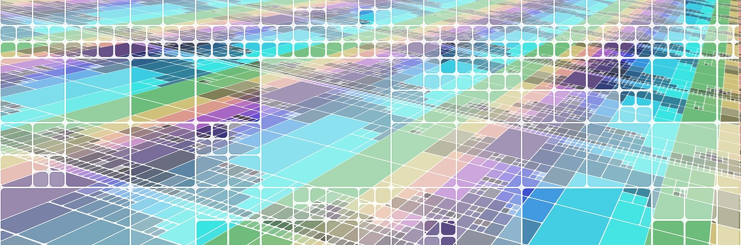
Source: Calibri italic 8pt, aligned left

Suspendisse potenti. Nulla nec rutrum tortor. Nulla dui sapien, cursus sed iaculis nec, elementum vel augue. Donec sit amet dui pulvinar, ultricies urna eu, gravida est. In ullamcorper, augue non egestas mattis, odio lacus rutrum felis, non ultrices diam sapien non sem. Etiam auctor facilisis euismod. Ut tempus nisi ut laoreet pharetra. Praesent elementum mauris neque, vitae commodo metus finibus id. Suspendisse sagittis aliquam dui a aliquet. Cras faucibus in purus quis aliquam. Orci varius natoque penatibus et magnis dis parturient montes, nascetur ridiculus mus. Nulla dictum varius metus. Ut id risus at dui luctus porta ut ut ante. Aenean bibendum scelerisque odio at efficitur.
(…)

Tables and figures should be numbered and references to them must be in the text. Acceptable labelling for a table is Tab.1 and Fig. 1 for a figure.
Table 1: Descriptive title (Calibri italic 10pt, centered)

Calibri 10pt | Calibri 10pt | Calibri 10pt
Calibri 10pt | Calibri 10pt | Calibri 10pt
Calibri 10pt | Calibri 10pt | Calibri 10pt
Calibri 10pt | Calibri 10pt | Calibri 10pt
Source: Calibri italic 8pt, aligned left

Equations
Equations (refer with: Eq. 1, Eq. 2,...) should be placed in the middle, denoted by numbers in round parentheses and transformed by equation conversion manager, do not use Print Screen or jpg format. For example:
(1)

ACKNOWLEDGMENT
Text: Calibri 10pt justified; 13pt line spacing. Lorem ipsum dolor sit amet, consectetur adipiscing elit. Morbi vulputate porta tristique. Suspendisse dictum iaculis molestie. Lorem ipsum dolor sit amet, consectetur adipiscing elit. Vivamus id congue metus. Aliquam commodo tristique dictum. Aliquam dapibus sem eu semper vulputate. Sed eget enim tellus. Vestibulum laoreet, elit id condimentum euismod, justo ex ullamcorper ipsum, at vehicula neque neque non massa. Phasellus gravida felis justo, ac suscipit leo finibus in.

REFERENCES
References in text should have this form (surname, year).
For example:
1 author: (Smith, 2012)
1 author and the same year of publication: (Smith 2012, A), (Smith, 2012, B)
2 authors: (Smith & Jones, 2014)
3 authors: (Brown et al., 2012)

For each work shown in the list of references must be a reference in the text. All citations in the text and all references must meet APA styles (American Psychological Association 6th edition – more information http://www.apastyle.org/).

(Book style - Author, year. Title (in italics). Publisher, location of publisher.)
- James, A. and Brown, R., (1999). Networks for Optimization and Processing, 1st ed. Chichester, U.K.: Wiley.
- Smith, W. K. (1998). Linear Networks and Systems, Belmont, CA: Wadsworth, pp. 23-48.

(Journal - Author, year. Paper title. Journal name (in italics), volume and issue numbers, inclusive pages.)
- Moore, S., Morgan, B. and Taylor, P. M. (2013). “The biology of aging: Observations and principles,” IEEE Trans. on Neural Networks, vol. 4, pp. 70-88.
- Davies, B. M. (2017). The last light breaking: Life among Alaska's Inupiat Eskimos, European Journal of Operational Research, vol. 97, pp. 493-499.

(Online Sources style)
- Taylor, A. J. (August 1992). Friendship quality and social development. IEEE Trans. Plasma Sci. [Online]. 21(3). pp. 276-330. Available: http://www.halcyon.com/pub/journals/21ps03-taylor

(Conference paper or contributed volume - Author, year, paper title. Proceedings title (in italics). City, country, inclusive pages.)
- Beck, B. and Smith, J. (1994). Mood management across affective states: The hedonic contingency hypothesis. Proceedings of European Conference of Object-Oriented Programming. Bologna, Italy, pp. 39-47.

(…)

PLEASE RENAME DOCUMENT ACCORDING TO SURNAMES OF ALL AUTHORS.
For example: Smith_Jones_Brown_PAPER

Footnote Calibri 9 pt.

